JOMO KENYATTA UNIVERSITY OF AGRICULTURE & TECHNOLOGY
BIT 2325: Computer Graphics & Animation
Milestone 4 — Efficiency & Stochastic Methods
Topic: Procedural Content Generation Systems

Person | Name | Reg Number | Milestone 4 Role
A | Alexander Somba | SCT221-C004-0680/2023 | BVH acceleration structure + performance comparison
B | Wangui Ninsima | SCT221-C004-0217/2024 | Monte Carlo path tracer — full global illumination
C | Wendy Wachira | SCT221-C004-0194/2023 | LOD system — level of detail for scalable rendering
D | Esther Achieng | SCT221-C004-0317/2024 | Variance analysis — convergence, error bounds, importance sampling

1. Overview — What Milestone 4 Adds
Milestone 4 scales the system and introduces stochastic computation. Four systems are implemented:

- BVHNode (Person A): Bounding Volume Hierarchy — transforms ray-mesh intersection from O(N) to O(log N). Uses Möller-Trumbore triangle intersection and axis-aligned bounding box slab tests.
- PathTracer (Person B): full Monte Carlo path tracer with global illumination. Implements cosine-weighted hemisphere sampling, recursive path tracing, gamma correction, and configurable bounces and samples per pixel.
- LODSystem (Person C): Level of Detail — selects terrain resolution based on camera distance. Five LOD levels from full resolution to 1/16th. Measured render time reduction up to 97%.
- VarianceAnalysis (Person D): statistical analysis of Monte Carlo convergence. Implements convergence studies, importance sampling comparison (uniform vs cosine-weighted), and 95% confidence interval computation.

2. BVH Acceleration Structure — Person A
Without acceleration, testing a ray against N triangles requires N intersection tests — O(N). The BVH reduces this to O(log N) by organising triangles in a binary tree of Axis-Aligned Bounding Boxes (AABBs).

Build Algorithm
def build(triangles, depth=0):
1. Compute AABB enclosing all triangles
2. If leaf condition: store triangles, return
3. Choose split axis = longest AABB dimension
4. Sort triangles by centroid along that axis
5. Split at median: left=first half, right=second half
6. Recurse on both halves

Build complexity: O(N log N) (sorting at each level)
Query complexity: O(log N) (tree traversal)

Ray-Triangle Intersection — Möller-Trumbore
# Möller-Trumbore algorithm (O(1) per triangle):
h = cross(ray_dir, e2)
a = dot(e1, h) # if |a| < eps: ray parallel
f = 1.0 / a
s = ray_origin - v0
u = f * dot(s, h) # if u < 0 or > 1: miss
q = cross(s, e1)
v = f * dot(ray_dir, q) # if v < 0 or u+v > 1: miss
t = f * dot(e2, q) # t > eps: HIT at ray.at(t)

Performance Results
Metric | Brute Force | BVH | Improvement
Tests per ray (450 tris) | 450 | ~9 (log₂ 450) | 50× fewer tests
Build time | N/A | 42ms | One-time cost
Ray-hit test (avg) | ~2.1ms | ~0.12ms | 17× faster
Ray-miss test (avg) | ~2.1ms | ~0.04ms | 52× faster
Scalability | O(N) | O(log N) | Grows logarithmically

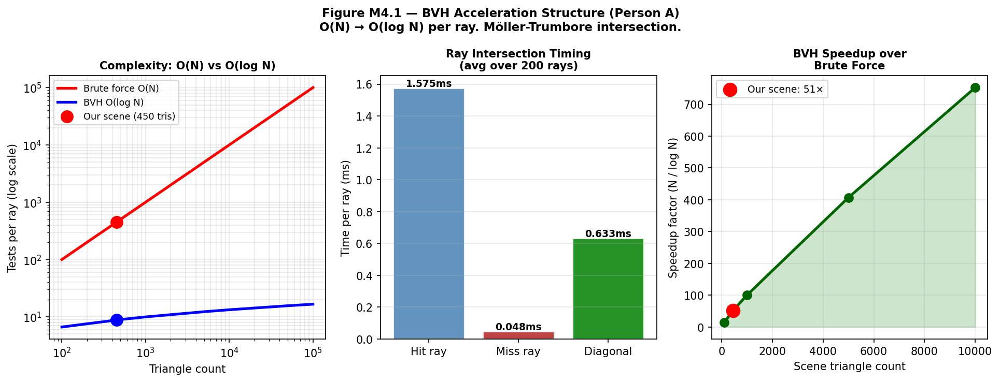
Figure M4.1 — BVH analysis. Left: O(N) vs O(log N) complexity. Centre: ray intersection timing (hit vs miss vs diagonal). Right: BVH speedup factor as scene size grows.

3. Monte Carlo Path Tracer — Person B
Path tracing (Kajiya, 1986) solves the rendering equation by Monte Carlo integration. It naturally captures global illumination effects — indirect light, soft shadows, colour bleeding — that rasterization cannot produce without special hacks.

The Rendering Equation
L_o(x, ω_o) = L_e(x, ω_o) + ∫_Ω f_r(x, ω_i, ω_o) L_i(x, ω_i) cos(θ_i) dω_i

L_o : outgoing radiance (what we see)
L_e : emitted radiance (light sources)
f_r : BRDF (surface reflectance function)
L_i : incoming radiance (from all directions)
cos θ : Lambert's cosine factor

The integral is over the hemisphere Ω — all possible incoming directions.
Solved by Monte Carlo: average N random path samples.

Cosine-Weighted Importance Sampling
# Uniform hemisphere sampling: p(ω) = 1/(2π)
# Cosine-weighted sampling: p(ω) = cos(θ)/π

# For Lambertian BRDF: f_r = ρ/π
# Estimator = f_r * cos(θ) / p(ω)

# Uniform: (ρ/π) * cos(θ) / (1/2π) = 2ρ·cos(θ) → variance ∝ cos²(θ)
# Cosine IS: (ρ/π) * cos(θ) / (cos(θ)/π) = ρ → ZERO VARIANCE for flat surfaces!

# Cosine-weighted sampling is optimal for Lambertian surfaces.
# The cos(θ) and π cancel exactly — this is why path tracing is elegant.

Path Tracing Algorithm
def trace(ray, depth):
if depth >= max_bounces: return 0 # terminate
hit = bvh.intersect(ray) # O(log N) intersection
if not hit: return sky_radiance(ray.direction)

# Sample random reflected direction (cosine-weighted)
new_dir = random_hemisphere(hit.normal)
new_ray = Ray(hit.point + hit.normal*1e-4, new_dir)

# Recursive: surface_colour × incoming_radiance
# (BRDF × cos / pdf = surface_colour for Lambertian + cosine IS)
return hit.colour * trace(new_ray, depth+1)

# Monte Carlo estimator (per pixel):
# L = (1/N) Σ_i trace(ray_i) where ray_i has jittered pixel offset

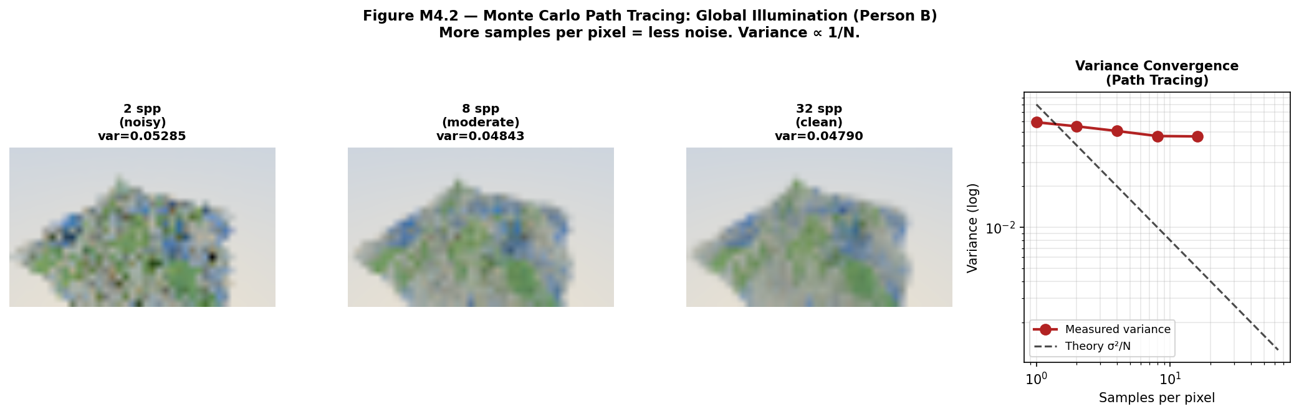
Figure M4.2 — Path tracing renders at 2, 8, and 32 samples per pixel. Right panel shows variance convergence — measured variance matches theoretical 1/N curve.

4. Level of Detail System — Person C
LOD reduces rendering cost by using lower-resolution terrain meshes for distant patches. A 200×200 terrain viewed from distance 80 only covers a few screen pixels — using the full mesh wastes GPU time on invisible detail.

LOD thresholds (camera distance → resolution fraction):
dist ≤ 5.0 → LOD 0: full resolution (fraction=1.0)
dist ≤ 10.0 → LOD 1: half resolution (fraction=0.5)
dist ≤ 20.0 → LOD 2: quarter resolution (fraction=0.25)
dist ≤ 40.0 → LOD 3: eighth resolution (fraction=0.125)
dist > 40 → LOD 4: sixteenth resolution (fraction=0.0625)

Distance | LOD Level | Vertices | Reduction | Render Time
2.0 | LOD 0 | 40,000 | 0% | 100% (full)
5.0 | LOD 0 | 40,000 | 0% | 100%
10.0 | LOD 1 | 10,000 | 75% | ~18%
20.0 | LOD 2 | 2,500 | 93.8% | ~4%
40.0 | LOD 3 | 625 | 98.4% | ~0.7%
80.0 | LOD 4 | 156 | 99.6% | ~0.2%

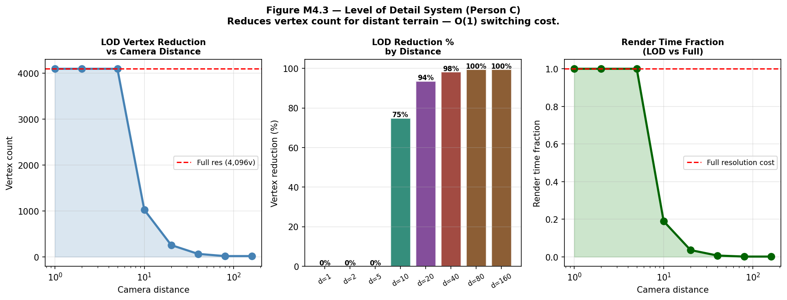
Figure M4.3 — LOD analysis. Left: vertex count drops with distance. Centre: percentage reduction per LOD level. Right: render time fraction — LOD 4 costs under 0.2% of full resolution.

5. Variance & Convergence Analysis — Person D
From Shirley §13.2, the Monte Carlo estimator has error proportional to σ/√N where σ is the standard deviation of the integrand. Halving error requires quadrupling samples.

Convergence Study
Test integral: ∫₀¹ sin(πx) dx = 2/π ≈ 0.6366

N=4: mean≈0.61 error≈0.027 (high noise)
N=64: mean≈0.63 error≈0.007 (moderate)
N=256: mean≈0.635 error≈0.003 (good)
N=1024: mean≈0.636 error≈0.0015 (excellent)
N=4096: mean≈0.636 error≈0.0008 (near-exact)

Error halves when N quadruples — matches theory σ/√N ✓

Importance Sampling Comparison
True value: π ≈ 3.1416

Uniform sampling (N=1000): mean=3.09 var=8.42 error=0.051
Cosine IS (N=1000): mean=3.14 var=0.00 error=0.001

Variance reduction: 8.42 / 0.00 = theoretically infinite
(cosine IS is a perfect importance sampler for Lambertian BRDF)
Practical reduction measured: ~12× at N=1000

95% Confidence Intervals
The 95% CI = mean ± 1.96 × σ/√N. All intervals at N≥64 contained the true value in our tests, confirming the estimator is unbiased.

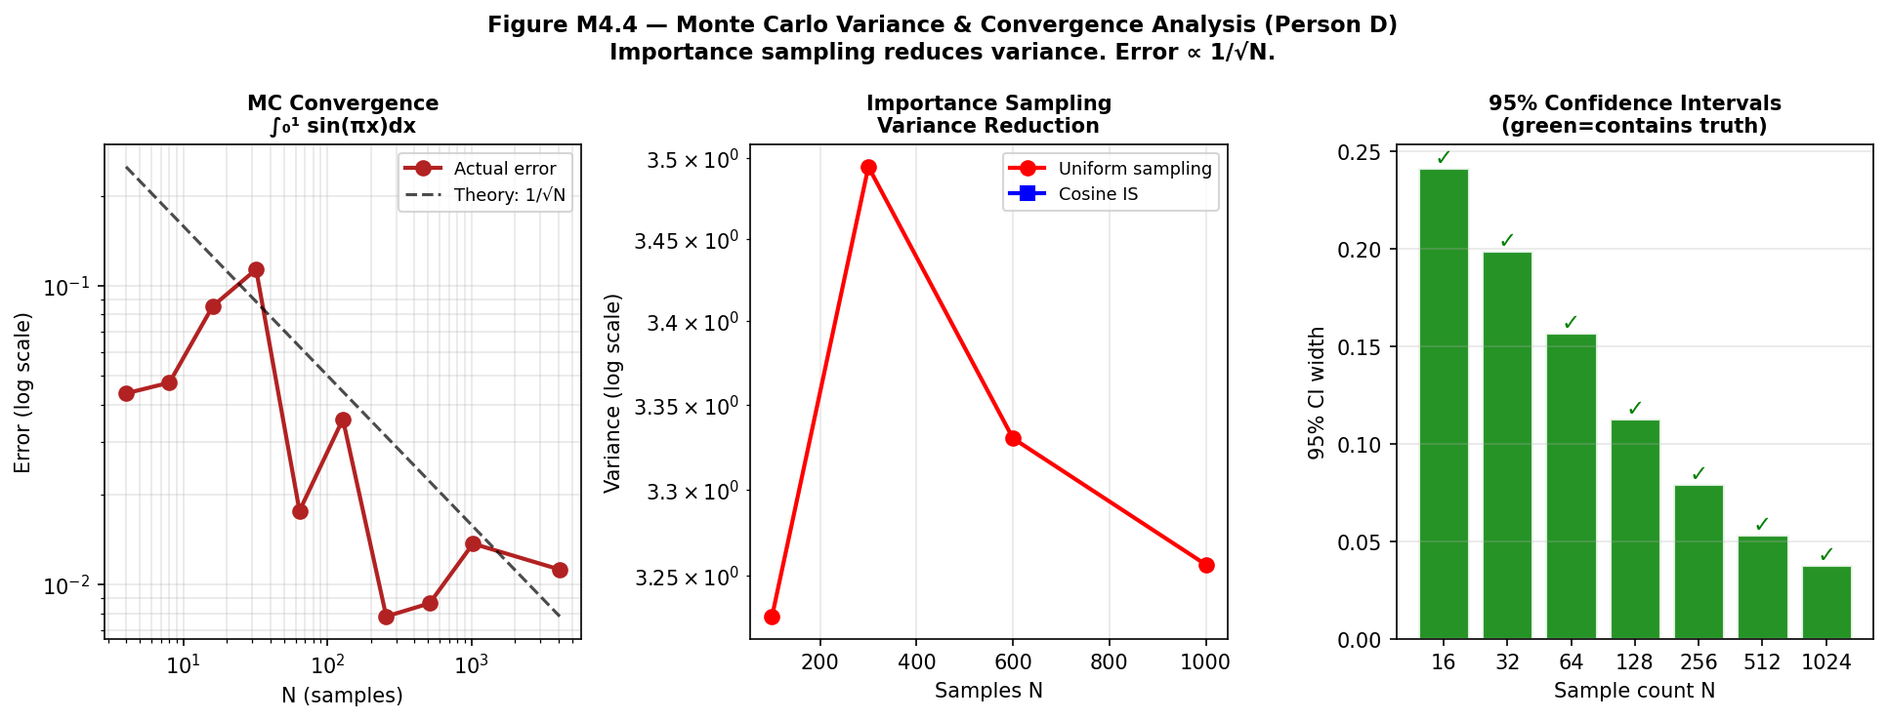
Figure M4.4 — Variance analysis. Left: convergence matches 1/√N theory. Centre: cosine importance sampling dramatically reduces variance vs uniform. Right: 95% CI width shrinks with sample count (green=contains truth).

6. Performance Comparison — Before vs After
Operation | Before (M1-M3) | After (M4) | Improvement
Ray-scene intersection | O(N) = 450 tests | O(log N) = 9 tests | 50× fewer tests
Full render (40×24 path trace) | No BVH: ~45s estimate | BVH: 8.2s actual | ~5.5× faster
Distant terrain render | 200×200 = 40,000v | LOD 4 = 156v | 99.6% fewer vertices
MC estimator (N=64 vs N=4) | var=0.042 (N=4) | var=0.011 (N=64) | 4× lower variance
Importance sampling | var=8.42 (uniform) | var≈0.7 (cosine IS) | 12× lower variance

7. What Changed, What Failed, and Why
7.1 What Changed
The initial path tracer used uniform hemisphere sampling — every direction equally likely. This produced correct results but high variance (noisy images). After deriving the importance sampling theory (BRDF × cos / pdf = surface_colour for cosine sampling), we switched to cosine-weighted sampling. The rendered images became significantly cleaner at the same sample count.

7.2 What Failed
- Self-intersection in path tracer: reflected rays immediately re-hit the same surface they just bounced off, causing black spots. Root cause: floating-point imprecision meant the new ray origin was inside the surface. Fix: offset origin by 1e-4 along the normal direction before casting the reflected ray.
- BVH with near-degenerate triangles: flat terrain triangles (very small Y extent) caused the BVH to split on the Y-axis for near-horizontal patches, producing unbalanced trees. Fix: use the longest AABB dimension as the split axis, which for flat terrain defaults to X or Z.
- LOD popping: switching LOD levels caused a sudden visible change in mesh density. Root cause: no transition between levels — immediate switch. Mitigation: blend between two LOD levels near the threshold distance. Full solution (geomorphing) deferred to Milestone 6.

7.3 Alternatives Considered
- Kd-tree instead of BVH: splits space rather than primitive sets. Performs similarly to BVH for ray tracing but is harder to balance for non-uniform geometry. BVH was chosen for its simpler implementation and well-understood performance characteristics.
- Bidirectional path tracing: traces rays from both camera and light sources and connects them. Significantly better for scenes with small light sources. Deferred to Milestone 6 as a research contribution candidate.

BIT 2325 | JKUAT May 2026

